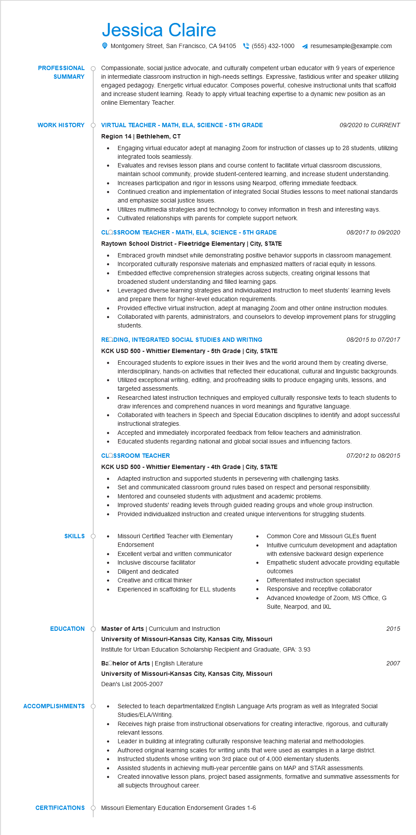
PROFESSIONAL
SUMMARY
WORK HISTORY
SKILLS
Jessica Claire
Montgomery Street, San Francisco, CA 94105(555) 432-1000
resumesample@example.com
Compassionate, social justice advocate, and culturally competent urban educator with 9 years of experience in intermediate classroom instruction in high-needs settings. Expressive, fastidious writer and speaker utilizing engaged pedagogy. Energetic virtual educator. Composes powerful, cohesive instructional units that scaffold and increase student learning. Ready to apply virtual teaching expertise to a dynamic new position as an online Elementary Teacher.
Ó VIRTUAL TEACHER - MATH, ELA, SCIENCE - 5TH GRADE
Region 14 | Bethlehem, CT
09/2020 to CURRENT
Engaging virtual educator adept at managing Zoom for instruction of classes up to 28 students, utilizing integrated tools seamlessly.
Evaluates and revises lesson plans and course content to facilitate virtual classroom discussions, maintain school community, provide student-centered learning, and increase student understanding. Increases participation and rigor in lessons using Nearpod, offering immediate feedback.
Continued creation and implementation of integrated Social Studies lessons to meet national standards and emphasize social justice Issues.
Utilizes multimedia strategies and technology to convey information in fresh and interesting ways. Cultivated relationships with parents for complete support network.
CLASSROOM TEACHER - MATH, ELA, SCIENCE - 5TH GRADE Raytown School District - Fleetridge Elementary | City, STATE
•
08/2017 to 09/2020
• Embraced growth mindset while demonstrating positive behavior supports in classroom management. Incorporated culturally responsive materials and emphasized matters of racial equity in lessons. Embedded effective comprehension strategies across subjects, creating original lessons that broadened student understanding and filled learning gaps.
Leveraged diverse learning strategies and individualized instruction to meet students' learning levels and prepare them for higher-level education requirements.
Provided effective virtual instruction, adept at managing Zoom and other online instruction modules. Collaborated with parents, administrators, and counselors to develop improvement plans for struggling students.
READING, INTEGRATED SOCIAL STUDIES AND WRITING
KCK USD 500 - Whittier Elementary - 5th Grade | City, STATE
•
08/2015 to 07/2017
Encouraged students to explore issues in their lives and the world around them by creating diverse, interdisciplinary, hands-on activities that reflected their educational, cultural and linguistic backgrounds. Utilized exceptional writing, editing, and proofreading skills to produce engaging units, lessons, and targeted assessments.
Researched latest instruction techniques and employed culturally responsive texts to teach students to draw inferences and comprehend nuances in word meanings and figurative language.
Collaborated with teachers in Speech and Special Education disciplines to identify and adopt successful instructional strategies
Accepted and immediately incorporated feedback from fellow teachers and administration.
• Educated students regarding national and global social issues and influencing factors.
CLASSROOM TEACHER
KCK USD 500 - Whittier Elementary - 4th Grade | City, STATE
•
•
•
•
07/2012 to 08/2015
Adapted instruction and supported students in persevering with challenging tasks. Set and communicated classroom ground rules based on respect and personal responsibility. Mentored and counseled students with adjustment and academic problems.
Improved students' reading levels through guided reading groups and whole group instruction. Provided individualized instruction and created unique interventions for struggling students.
Missouri Certified Teacher with Elementary Endorsement
Excellent verbal and written communicator Inclusive discourse facilitator
Diligent and dedicated
Creative and critical thinker
Experienced in scaffolding for ELL students
Common Core and Missouri GLEs fluent Intuitive curriculum development and adaptation with extensive backward design experience Empathetic student advocate providing equitable outcomes
Differentiated instruction specialist
Responsive and receptive collaborator
Advanced knowledge of Zoom, MS Office, G Suite, Nearpod, and IXL
EDUCATION
Master of Arts | Curriculum and Instruction
ACCOMPLISHMENTS
CERTIFICATIONS
University of Missouri-Kansas City, Kansas City, Missouri
Institute for Urban Education Scholarship Recipient and Graduate, GPA: 3.93
Bachelor of Arts | English Literature
University of Missouri-Kansas City, Kansas City, Missouri
Dean's List 2005-2007
Selected to teach departmentalized English Language Arts program as well as Integrated Social Studies/ELA/Writing.
Receives high praise from instructional observations for creating interactive, rigorous, and culturally relevant lessons.
Leader in building at integrating culturally responsive teaching material and methodologies.
•
Authored original learning scales for writing units that were used as examples in a large district. Instructed students whose writing won 3rd place out of 4,000 elementary students.
Assisted students in achieving multi-year percentile gains on MAP and STAR assessments.
•
2015
2007
Created innovative lesson plans, project based assignments, formative and summative assessments for all subjects throughout career.
Missouri Elementary Education Endorsement Grades 1-6

